Chapter 2, Solution 13

I₂ 7A I₄
2A
1 2 3 4
4A
I₁
3A I₃

At node 2,
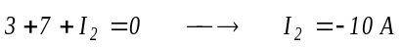
At node 1,
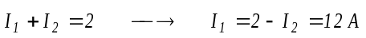
At node 4,
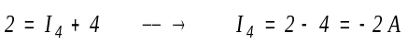
At node 3,
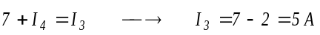
Hence,

